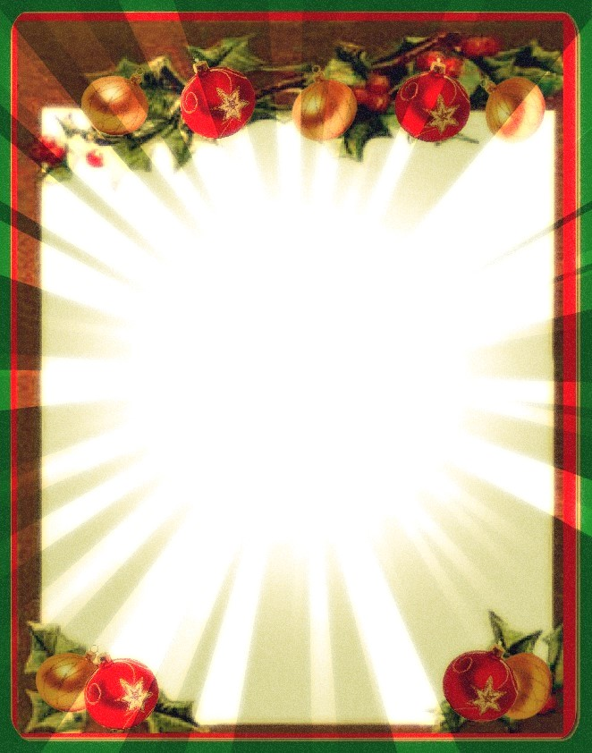

**Materials will be provided.**

**Each participant will make two (2) cards.**

**Workshop limited to twelve (12) people.**

***No fee for the workshop.***

**Please register at the  
circulation desk.**

**Christmas Card Workshop**

**Tuesday, November 14th**

**5:00 p.m. to 6:00 p.m.**